ANALYSIS REPORT

Q_1

Commence the initial stage by coding the core sorting algorithms, namely:
- In-Place Quick Sort (Pick the pivot as the first element)
- Merge Sort
- In-Place Heap Sort
- Bucket Sort
- Radix Sort
Afterward, create a series of random input test cases in diverse sizes, starting with a minimum of 100, and including 500 and 1000. Proceed to assess the efficiency of these algorithms using the criteria listed below:
- Number of comparisons (where applicable)
- Number of swaps (where applicable)
- Number of basic operations (other than the ones mentioned above)
- Execution time in milliseconds
- Memory usage
Following this analysis, provide your observations and conclusions.
The following report shows the analysis and the efficiency of the above mentioned sorting algorithms—Quick Sort, Heap Sort, Bucket Sort, and Radix Sort—based on their performance across various randomly generated input test cases. These test cases include diverse sizes, starting with a minimum of 100 elements and extending to 500 and 1000 elements.

- INPLACE HEAP
Heap Sort works by first constructing a max-heap from the input array, ensuring the maximum element is always at the root. It then repeatedly extracts the maximum element, places it in its correct position, and restores the heap property. This in-place sorting algorithm has a time complexity of O(n log n) and uses O(1) additional space, making it both time-efficient and space-efficient.
The snapshot below depicts the duration(in milliseconds), memory usage, and number of comparisons.
OUTPUT:
Input size=100
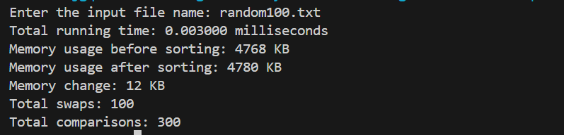
Input size=500
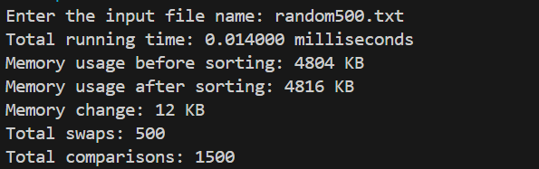
Input size=1000
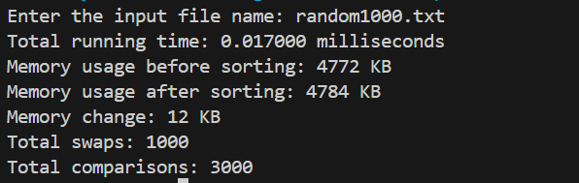
Complexity analysis:
Time Complexity:
Best Case: O(n*logn)
Worst Case: O(n*logn)
Average Case: O(n*logn)
Space Complexity: O(1)
Stability: No
EXECUTION TIME VS INPUT SIZE
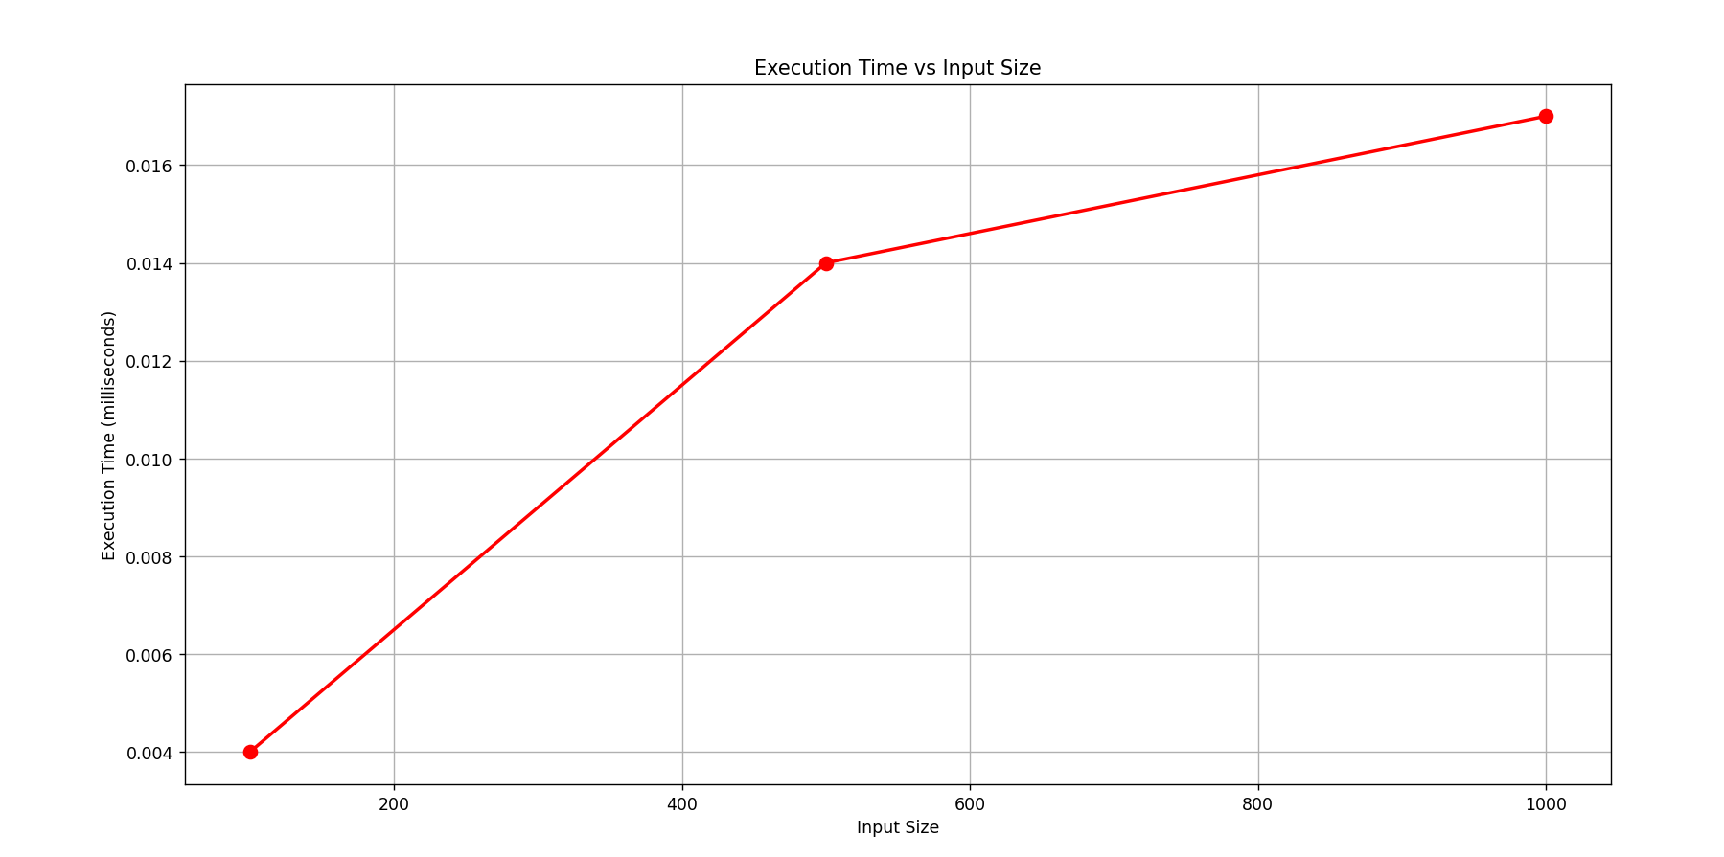

NUMBER OF SWAPS VS INPUT SIZE
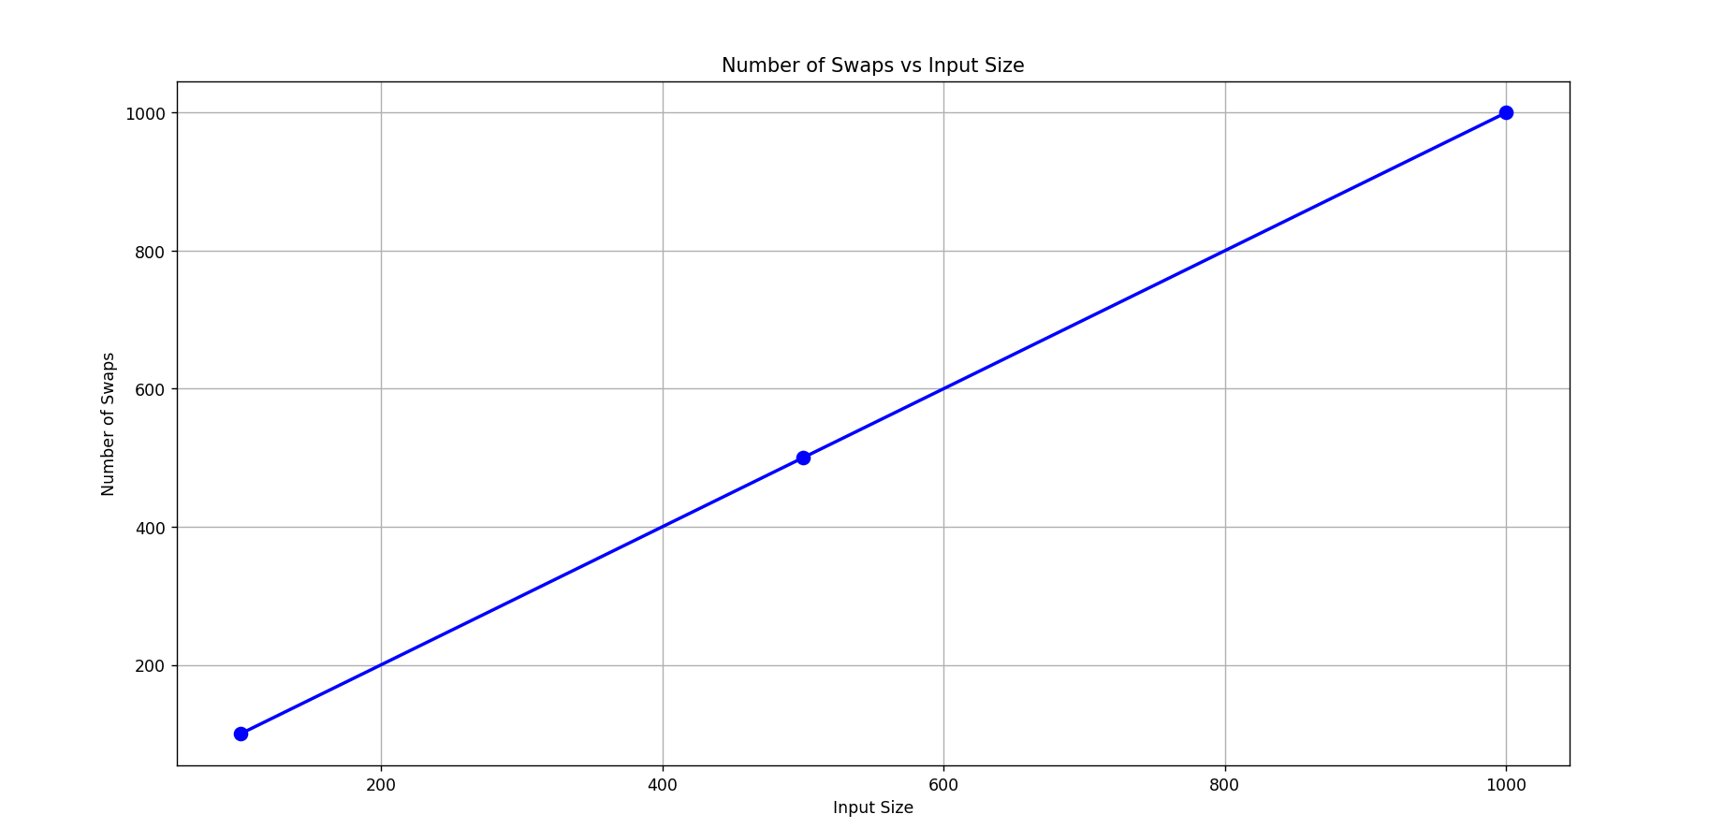
NUMBER OF COMPARISONS VS INPUT SIZE
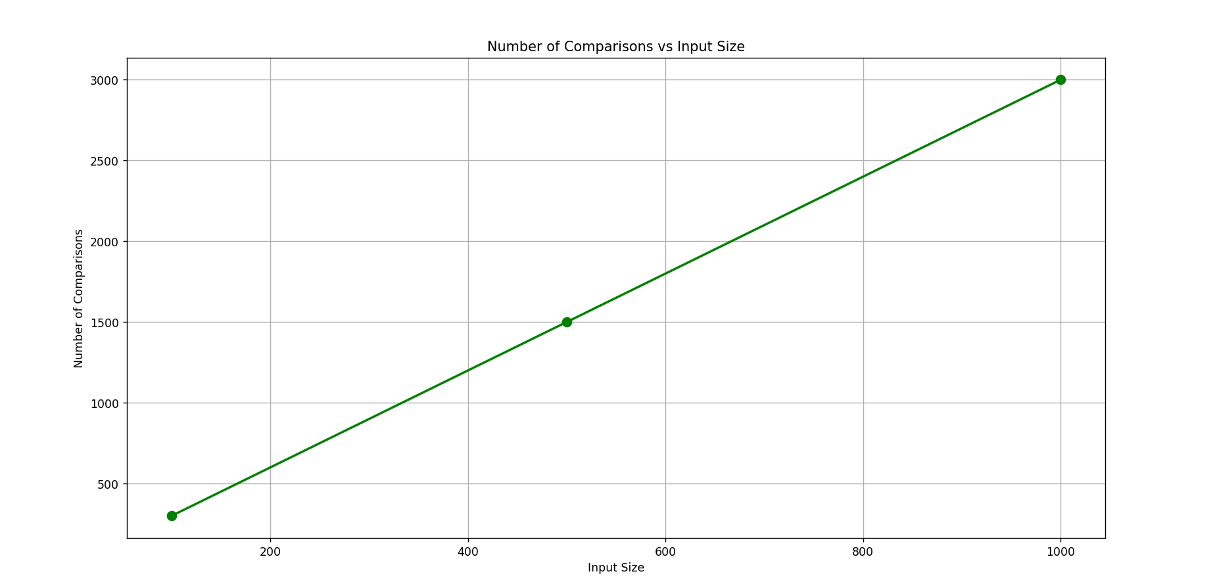

MEMORY CHANGE VS INPUT SIZE
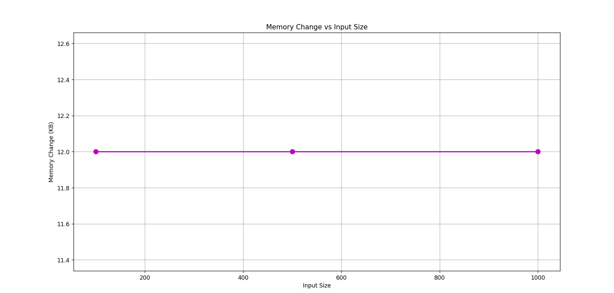
- In-Place QUICK SORT:
Using the first element as the pivot in Quick Sort is straightforward but can be inefficient, especially with sorted or nearly sorted arrays, leading to worst-case performance of O(n^2). For better performance, especially with varied input data (like 100,500,1000), consider using pivot strategies like random selection to achieve more balanced partitions and avoid worst-case scenarios. The snapshot below depicts the duration (in milliseconds), memory usage, and number of comparisons and number of swaps.
Input size=100
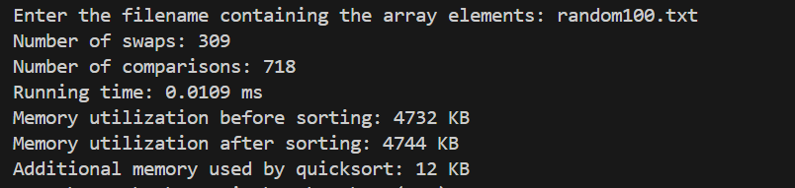
Input size=500
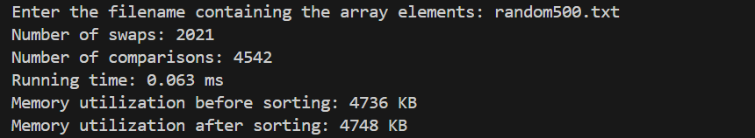
Input size=1000
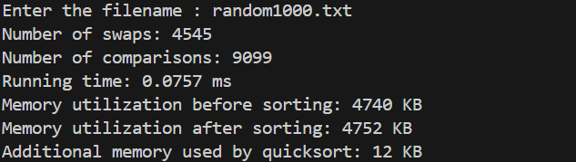

Complexity analysis:
Time complexity:
Best Case: O(n*logn)
Worst Case: O(n²)
Average Case: O(n*logn)
Space Complexity: O(logn) [same memory which is pointing the input array]
Stability: No
EXECUTION TIME VS INPUT SIZE
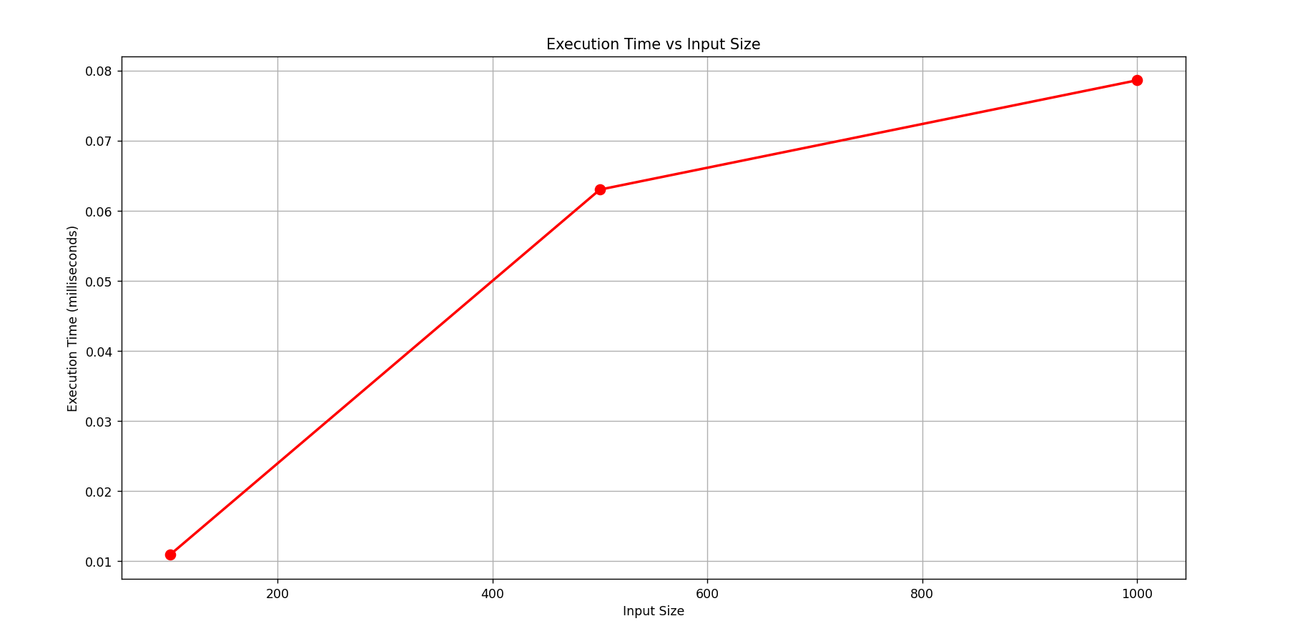
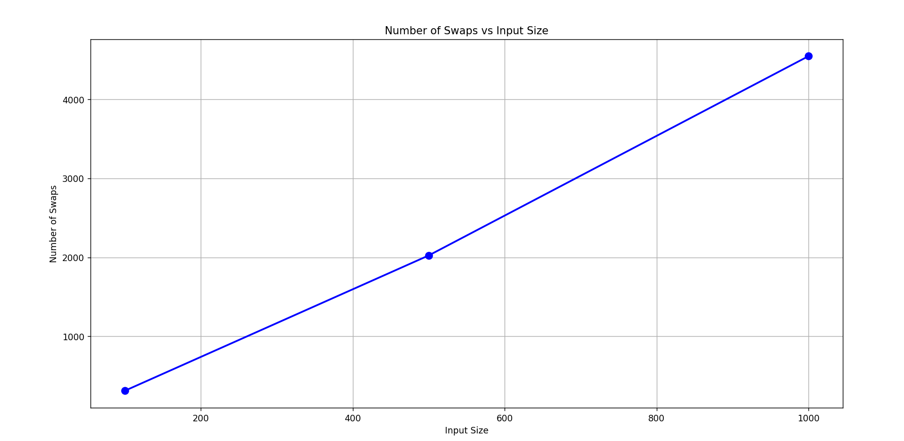
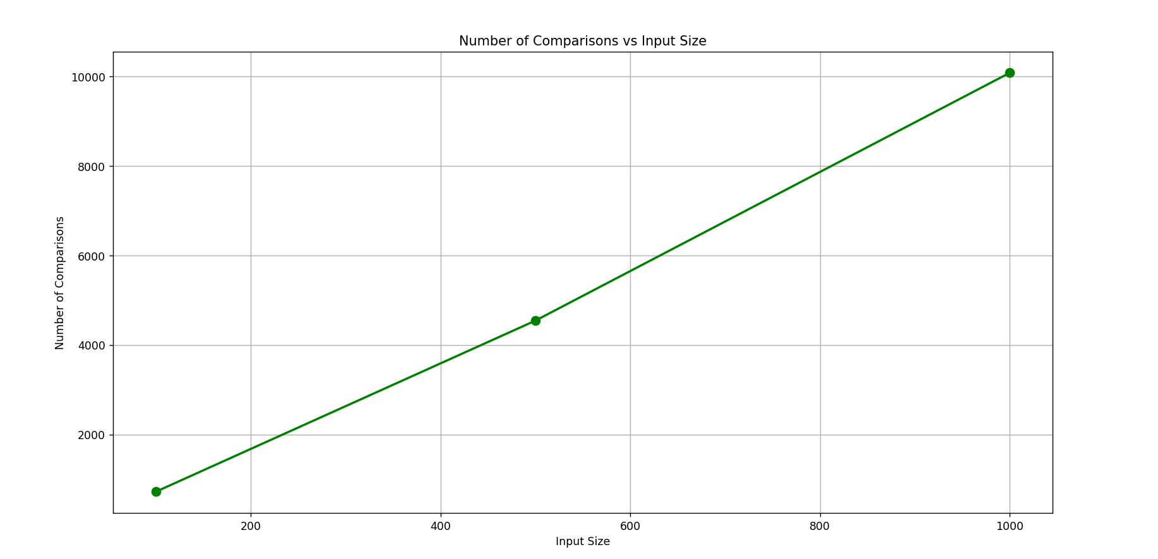
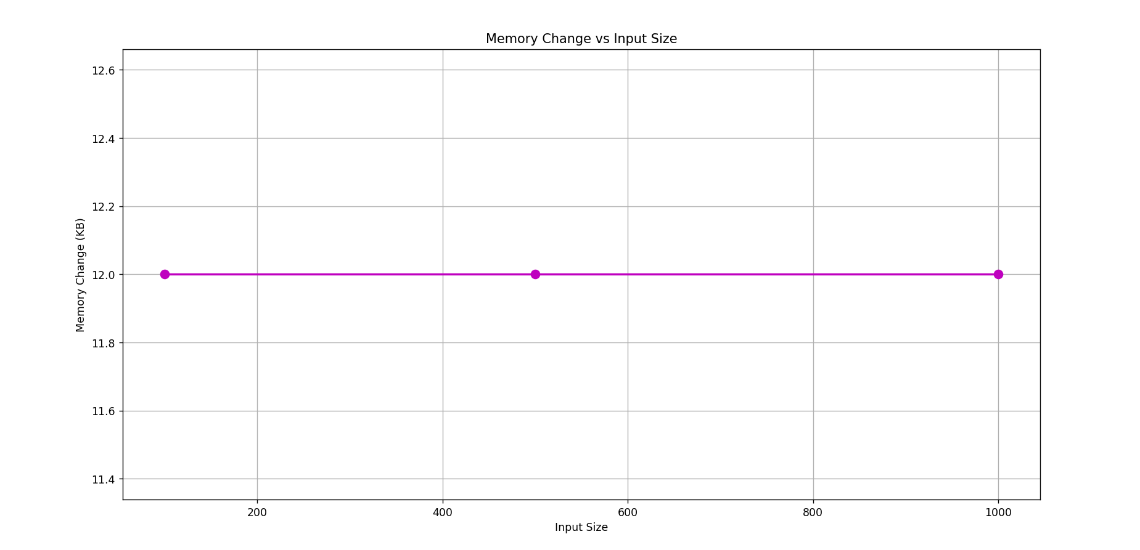

- BUCKET SORT:
It is a non-comparison sorting algorithm that divides the unsorted array elements into several groups called buckets. Each bucket is then sorted by using insertion sort. Finally, the sorted buckets are combined to form a final sorted array. The snapshot below depicts the duration(in milliseconds), memory usage, and number of comparisons and number of swaps.
Input size=100
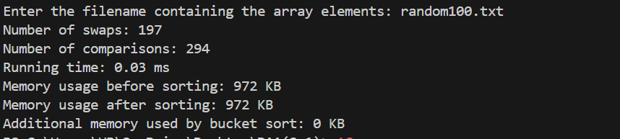
Input size=500
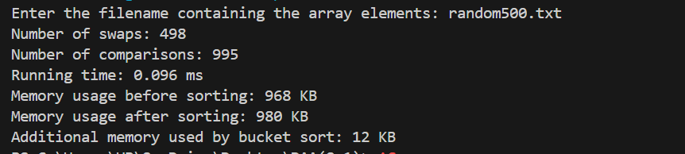
Input size=1000
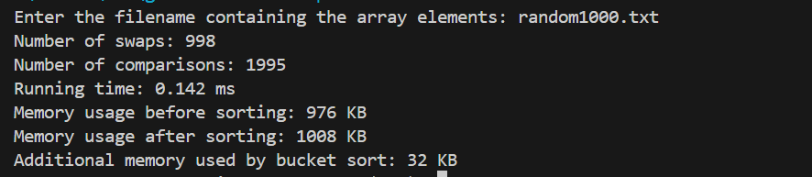
Complexity analysis:
Time Complexity:
Best Case: O(n+k) [here k is the number of buckets]
Worst Case: O(n²)
Average Case: O(n+k)
Space Complexity: O(n+k)
Stability: Yes

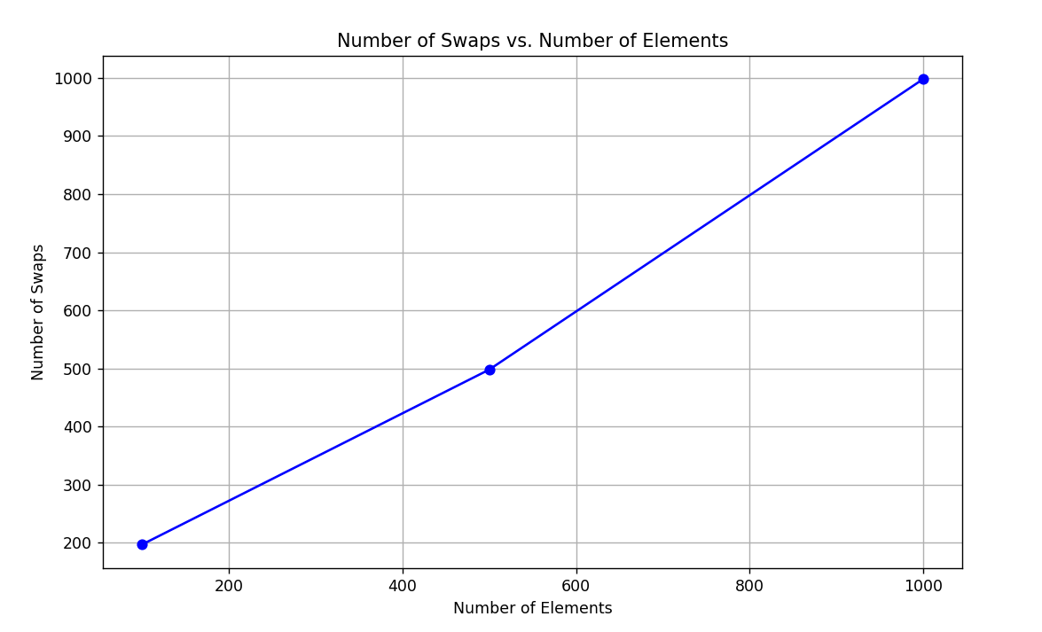

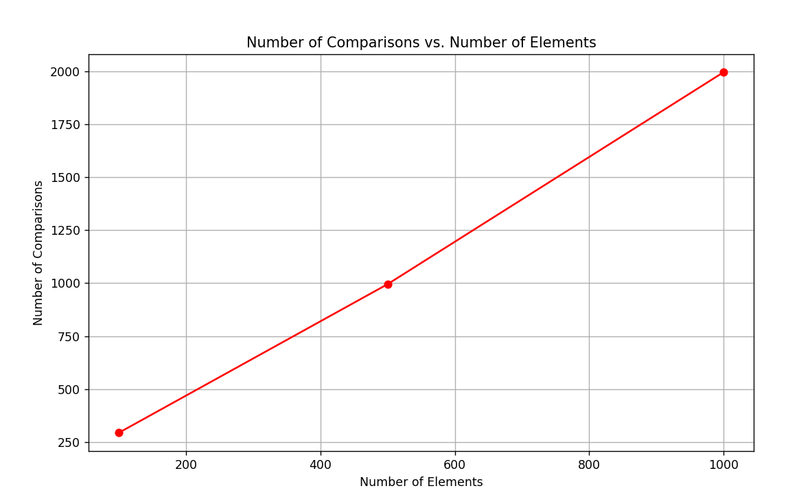
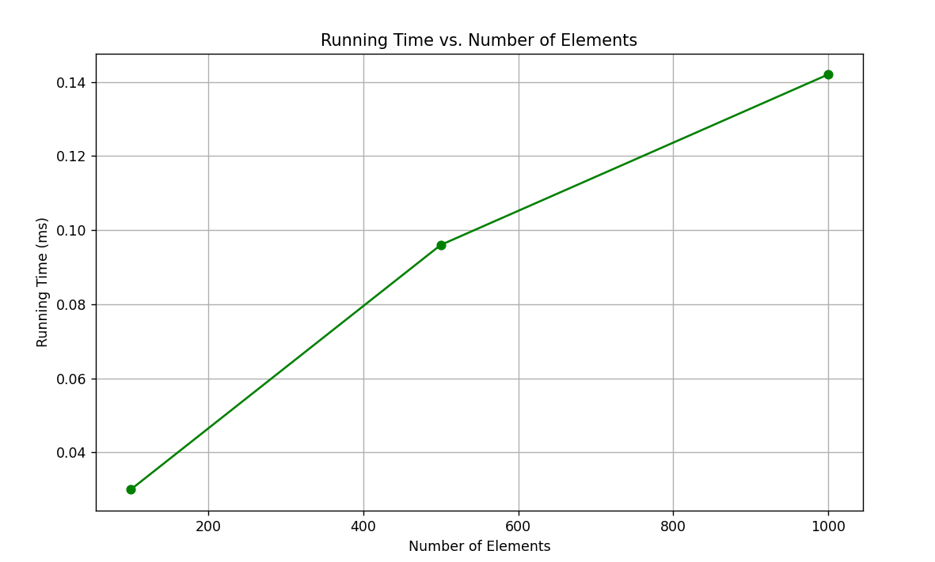
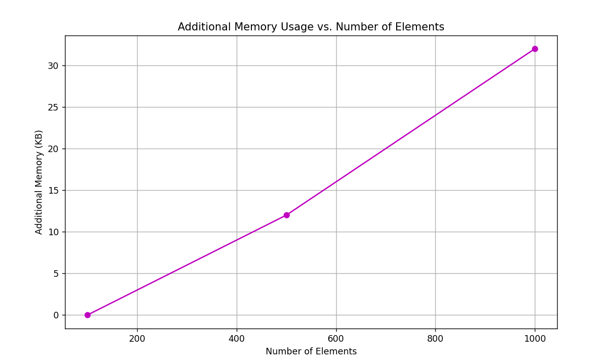

- RADIX SORT:
This non-comparison algorithm sorts the elements by first grouping the individual digits of the same place value using counting sort. Then, sorts the elements according to their increasing order. The snapshot below depicts the duration(in milliseconds), memory usage.
Input size=100
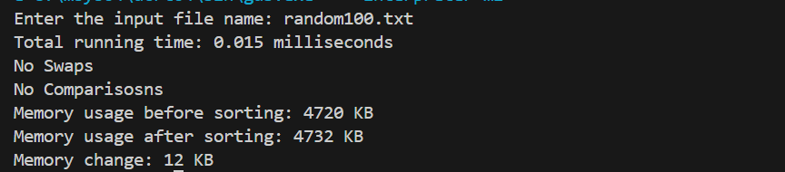
Input size=500
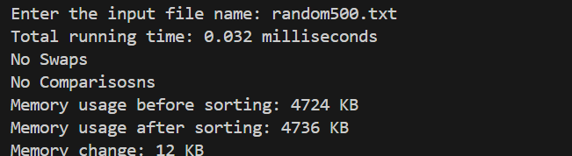
Input size=1000
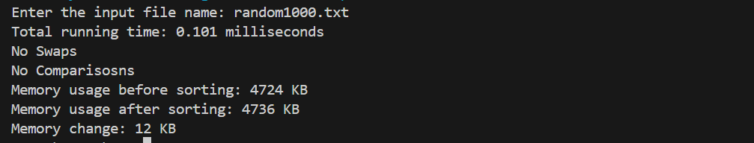
Complexity analysis:
Time Complexity:
Best Case: O(d(n+k)) [Here, d is the number cycle, O(n+k) is the time complexity of counting sort, and k is the number of possible digit values. ]
Worst Case: O(d(n+k))
Average Case: O(d(n+k))
Space Complexity: O(n+k)
Stability: Yes

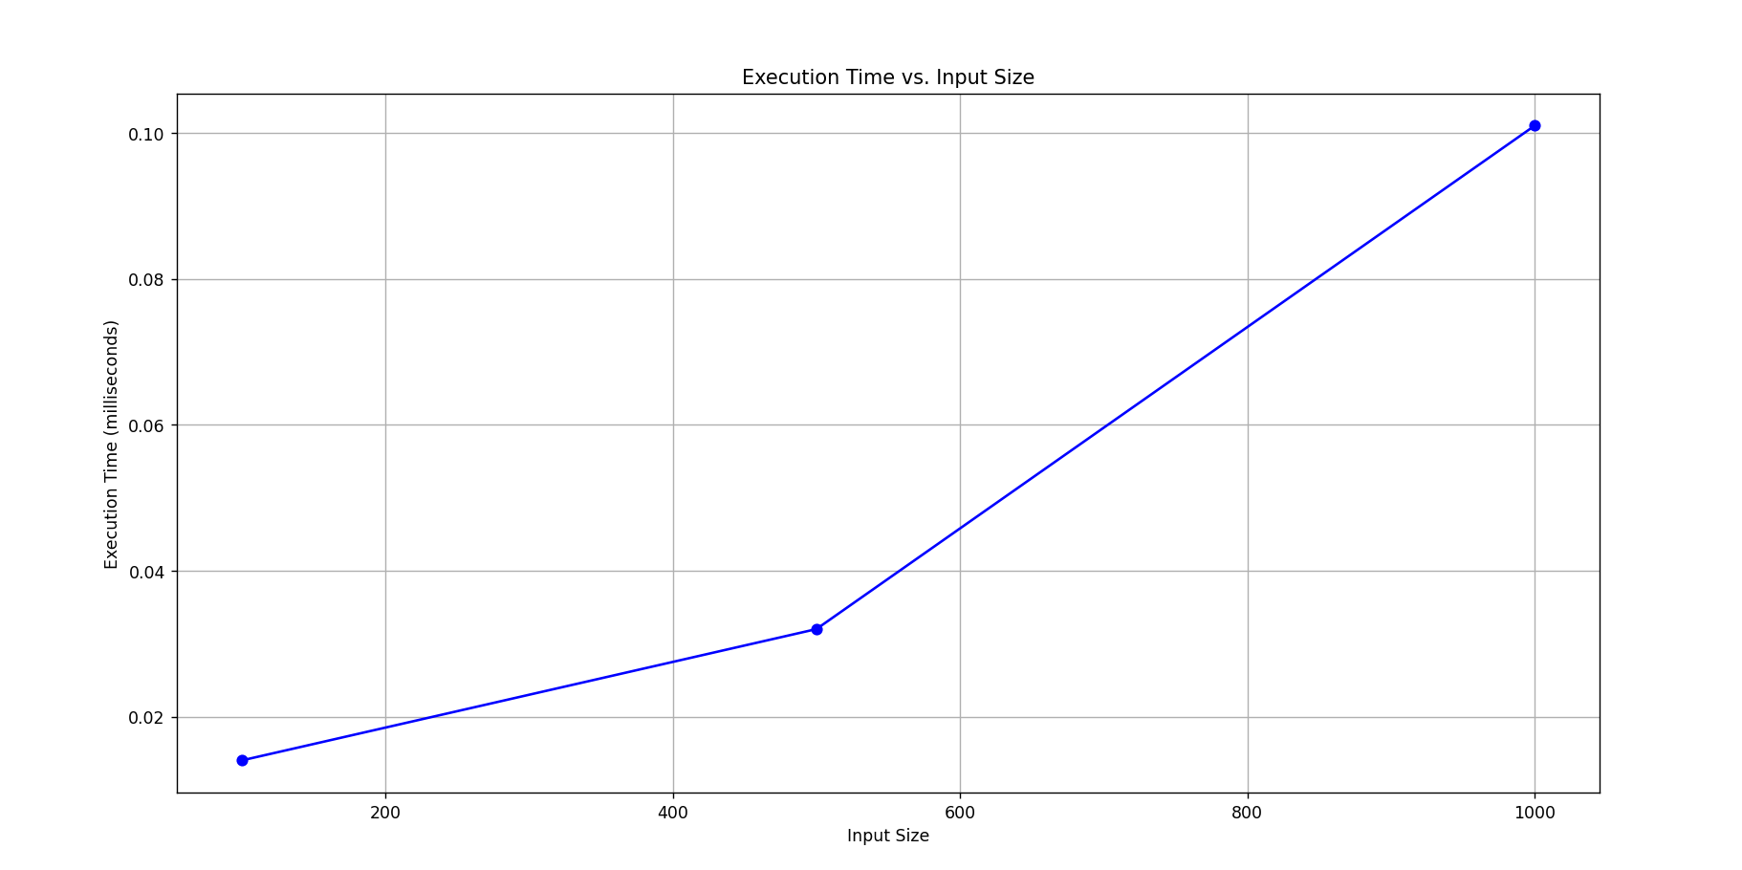

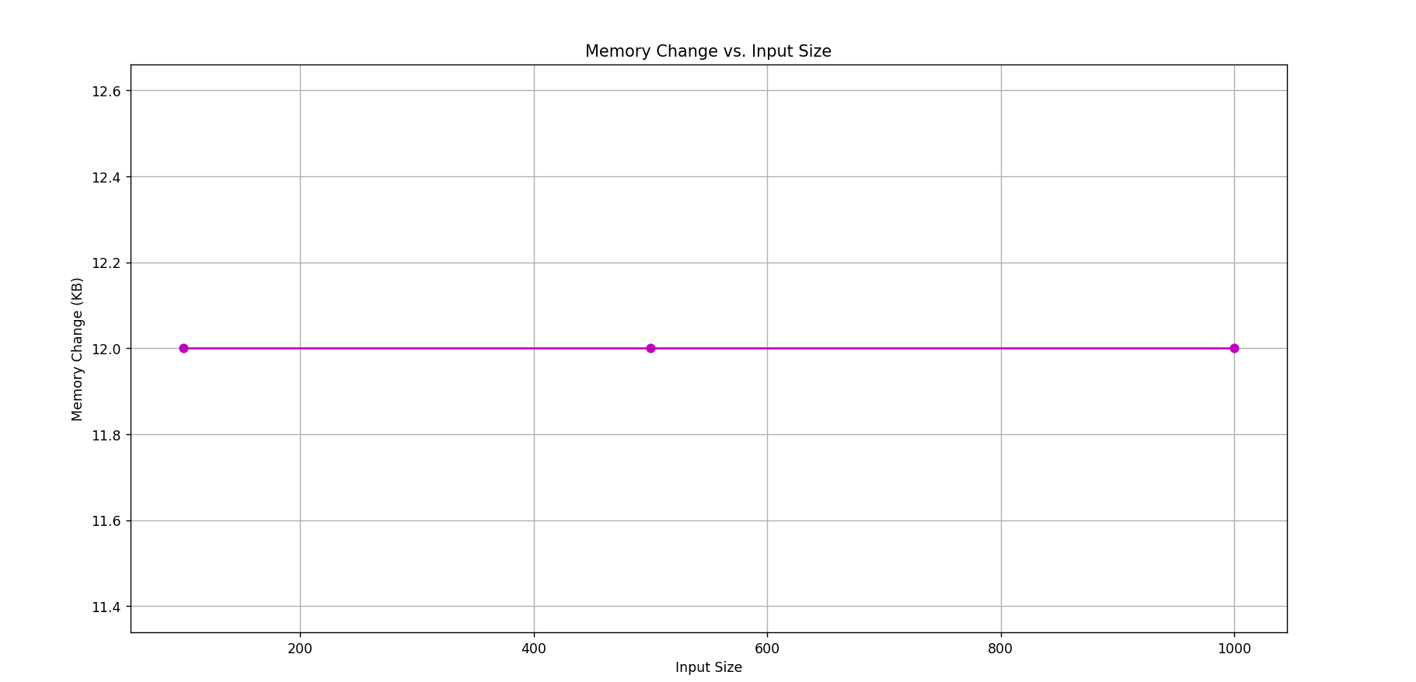

- Merge Sort
Merge Sort is a divide-and-conquer sorting algorithm that works by recursively splitting the array into smaller subarrays, sorting those subarrays, and then merging them back together into a single sorted array. This algorithm is particularly efficient for large datasets and has a consistent time complexity of O(n log n), making it one of the most efficient general-purpose sorting algorithms. The snapshot below depicts the duration(in milliseconds), memory usage, and number of comparisons.

Input size=100
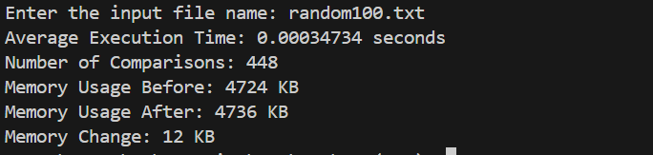

Input Size=500
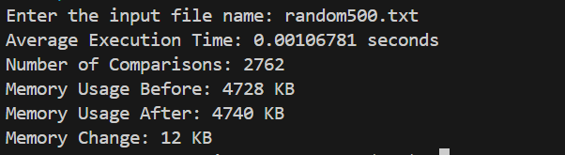

Input size=1000
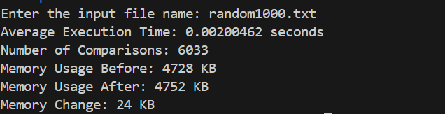

Complexity analysis:

Time Complexity:

- Best Case: O(n log n)

- Average Case: O(n log n)

- Worst Case: O(n log n)

Space complexity: O(n)

Stability:Yes

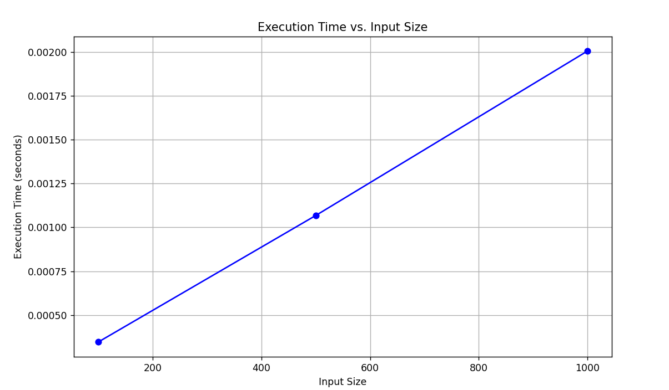
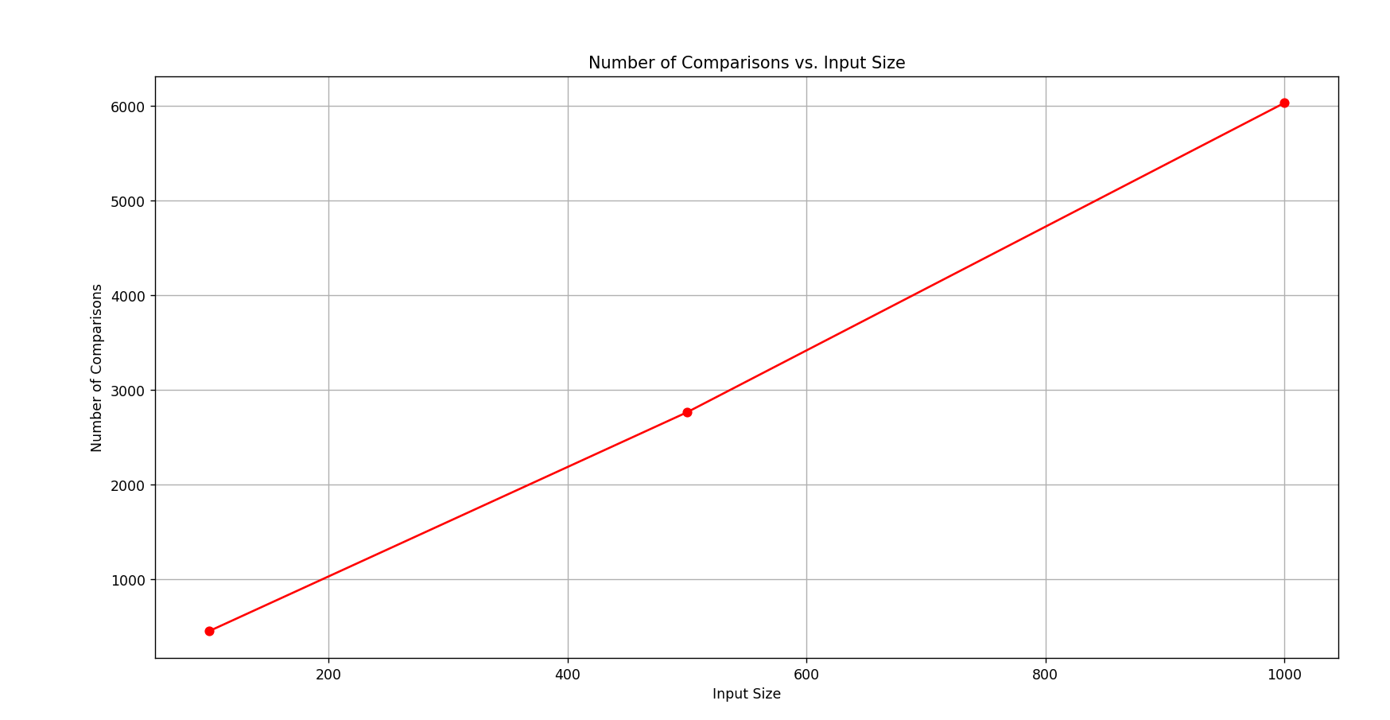

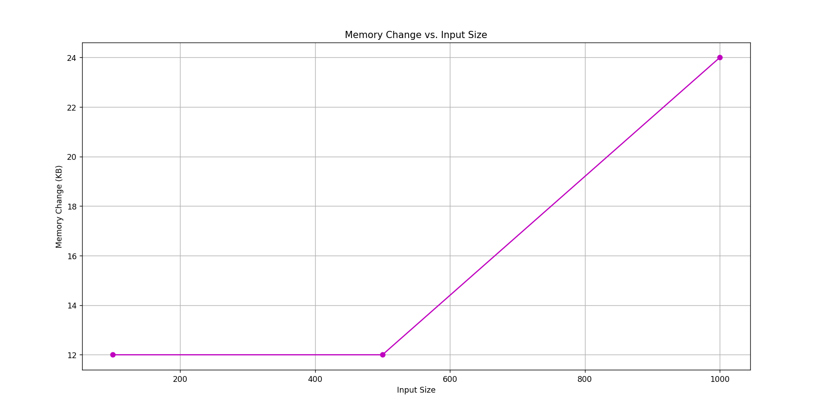

ANALYSIS:

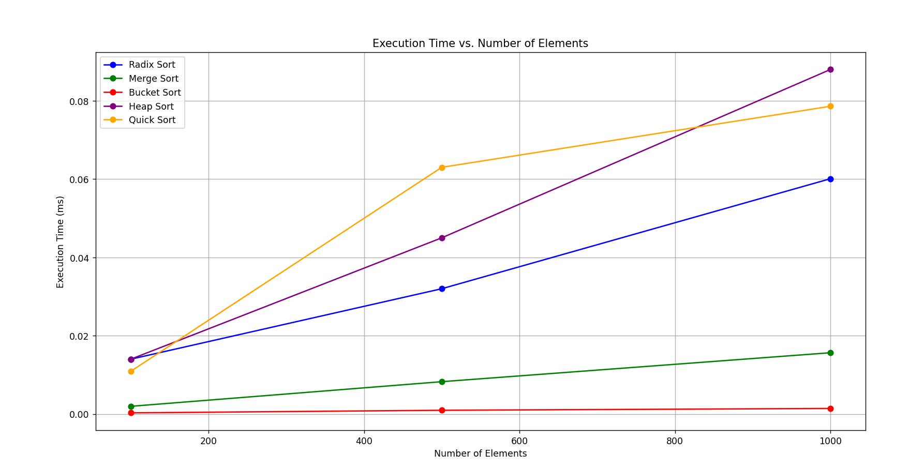

- In-Place Quick Sort is generally fast but shows a significant increase in time as input size increases, which might be affected by pivot selection.
- In-Place Heap Sort is generally reliable and predictable, but tends to be slower for larger inputs. Its performance is consistent but less efficient for very large datasets due to the overhead of maintaining the heap structure.
- Merge Sort ensures stable performance through its divide-and-conquer approach and merging strategy.
- Radix Sort maintains stability by sorting elements digit by digit, preserving the order of elements with the same key.
- Bucket Sort is very fast for small inputs and when the data is well distributed but slightly slower when the distribution of the data is uneven.

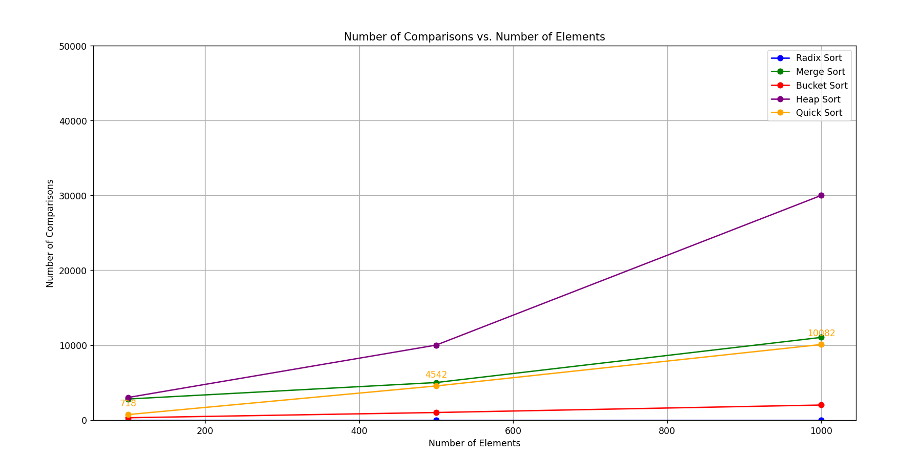
- In-Place Quick Sort can have more number of comparisons in the worst case
- Heap Sort requires more comparisons due to heapification process
- Merge Sort consistently use O(nlogn) comparisons.
- Radix Sort has minimum comparisons because it sorts based on individual digits rather than comparing whole numbers.
- Bucket sort also has minimum comparisons especially when the inputs are well distributed with a given range of buckets.

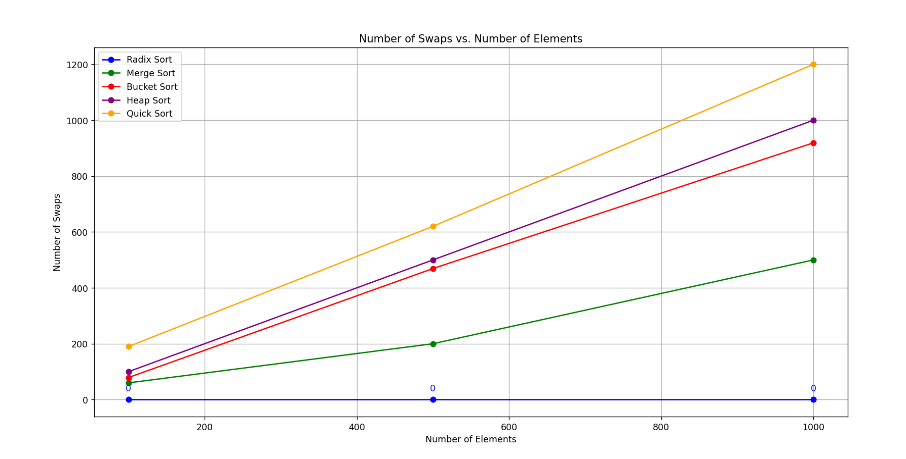
- Quick Sort can have the highest number of swaps, especially in the worst case (O(n²)), when the pivot is poorly chosen when it’s always being the smallest or largest element leading to inefficient partitioning and many unnecessary swaps.
- Heap Sort also exhibits the highest number of swaps, which is characteristic of heap operations where elements are continuously swapped to maintain heap properties.
- Bucket sort might need fewer swaps because it involves swapping within each bucket but it might require larger swaps in worst case when all the elements fall within the same bucket especially when the range of the buckets are not chosen properly
- Radix sort doesn’t require swapping because it uses digit based counting.
- Merge Sort doesn't rely on swaps like many other algorithms do. Instead, it focuses on splitting the array and merging them back together in a sorted order

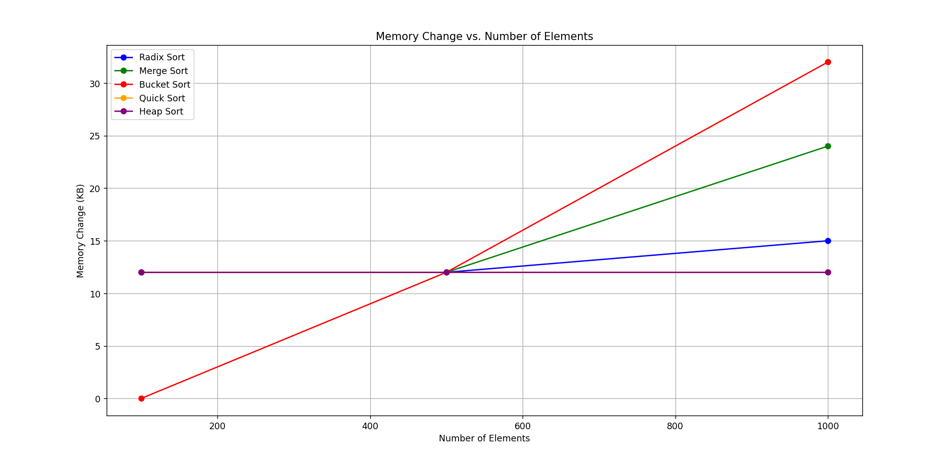

- Heap sort uses a constant amount of extra memory, keeping only a few additional variables. It sorts the array in place without needing extra storage.

- Merge sort requires additional memory for merging sorted subarrays. It uses extra space proportional to the size of the input array.

- Quick sort needs a small amount of extra memory for the steps it keeps track of during sorting. However, if the pivot selection is poor and leads to unbalanced splits, it can use more memory.

- Radix sort uses extra memory for counting and sorting digits or characters, O(n+k) where k is the range of digit values.

- Bucket sort uses extra memory for the buckets with complexity of O(n+k) where k is the number of buckets. It requires additional space proportional to the input size plus the number of buckets.

CONCLUSIONS:
- Radix sort is best suited For large datasets with integer keys or fixed-length strings, especially when the range of values is not too wide compared to the number of items.It handles uniformly distributed data well, where each element falls within a specific range of digits or characters. This makes it efficient and effective for sorting such types of data.

- Bucket Sort is best for uniformly distributed data where elements fall within a known range. It works well when you can easily divide the data into buckets and sort each bucket efficiently. This makes it particularly useful for datasets that are evenly spread out and where bucket sorting is practical.

- Heap Sort is best for scenarios where you need in-place sorting with a guaranteed O(nlogn) time complexity. It's ideal for large datasets when you want to minimize additional memory used.

- Merge Sort is best suited for large datasets or data with many duplicates because it offers consistent performance regardless of the initial order.

- In-Place Quick Sort offers good performance across different sizes but may not be as predictable due to its dependency on pivot selection. It remains memory efficient.

